AI-Driven Development - 30-Day Challenge-Task 6

NAME: KHURRAM SHAHZAD
ROLL # 00116199
CLASE SLOT: FRIDAY (6-9)pm
TAKE 6
Created Token on Github

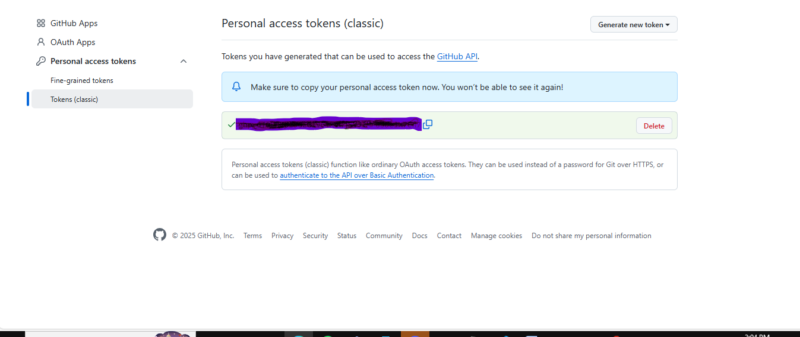

Added the MCP BLOCK and TAKEN in SETTING.JOSN
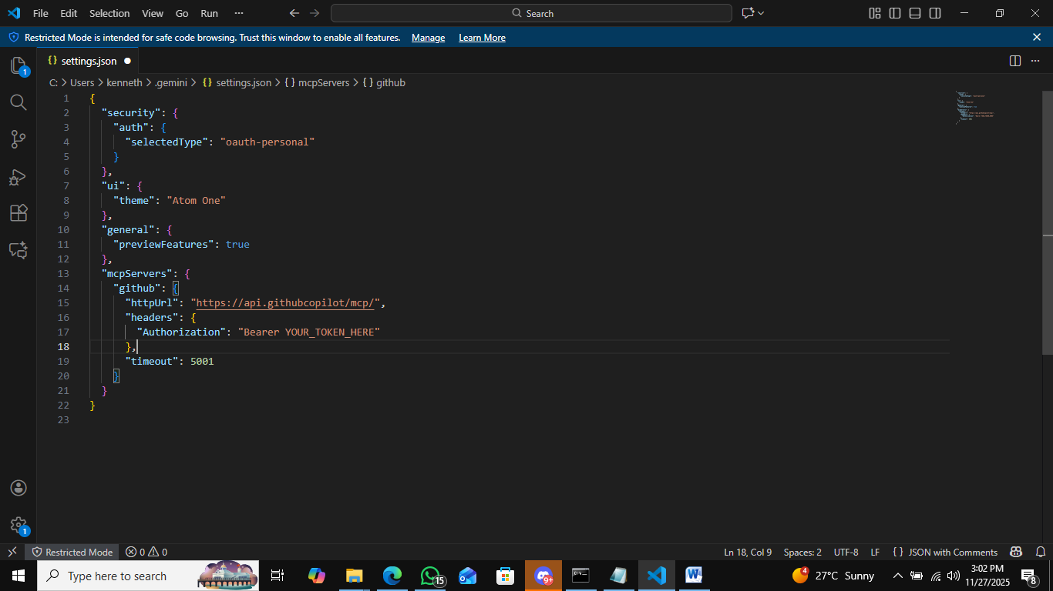

RUN GEMINI CLI in the TERMINAL

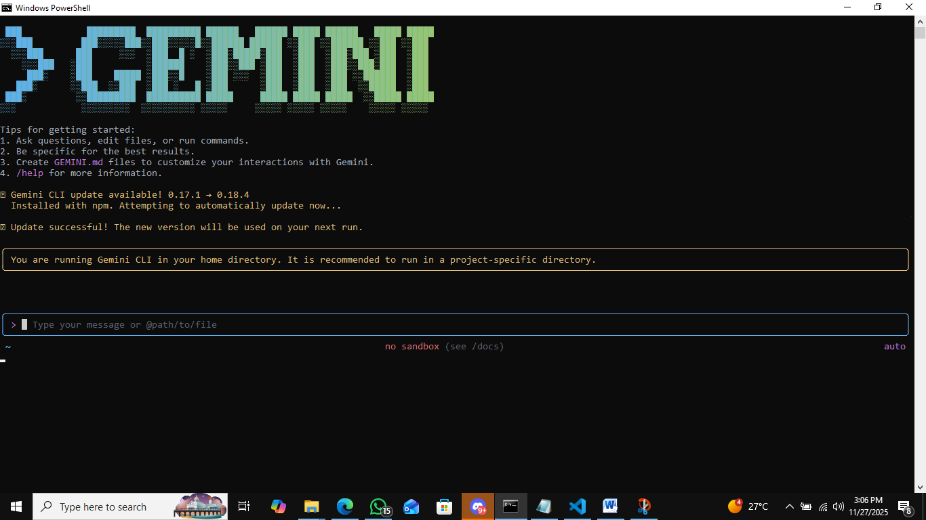
/MCP LISH RUN GITHUB MCP CONNECTED
